SOALAR **GLIDER** VEHICLE

Introduction :-

Solar Glider Vehicle is a type of Aircraft.It has speciality during fly it can charge itself without landing and can serveillancing.This is a Aircraft which can fly for a long time without landing after a single charge ,we have used such a system that the working capacity of the battery battery is one hour,we can fly it for 3-4 hour smoothly .is possible

Module Diagram :-

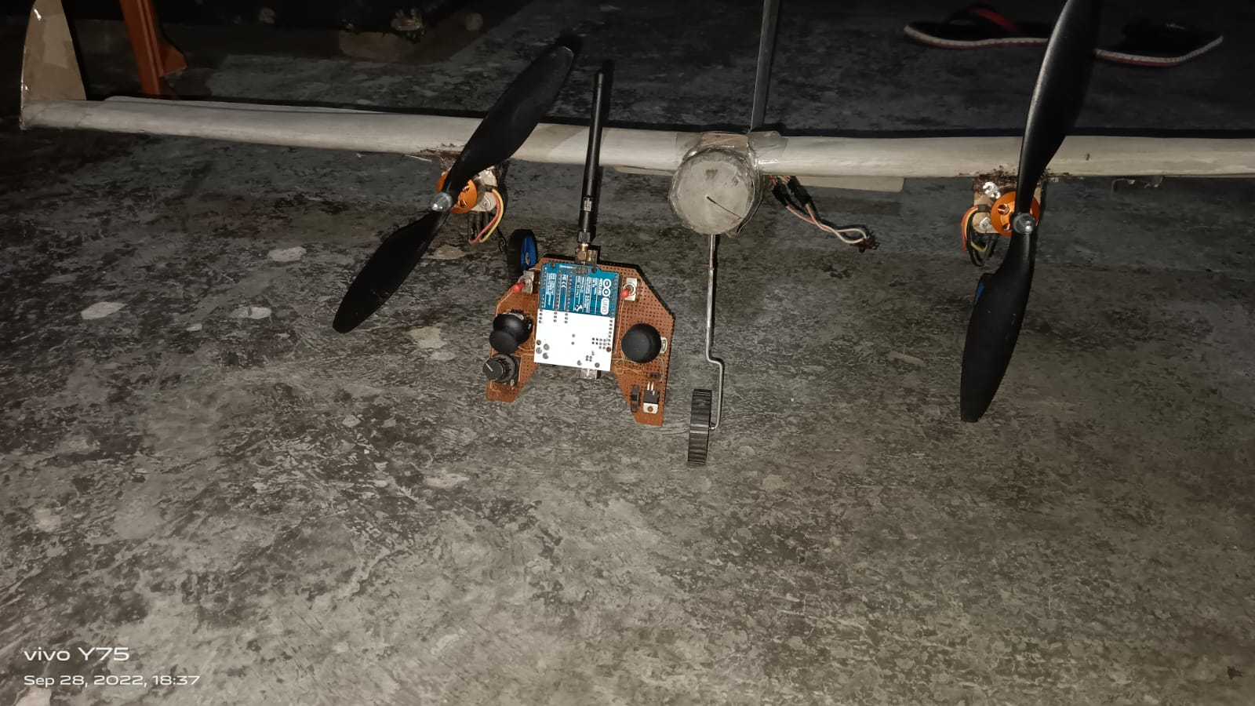

This is the model we have prepared for our project,we have kept its wing slightly large than other drones

Image 2

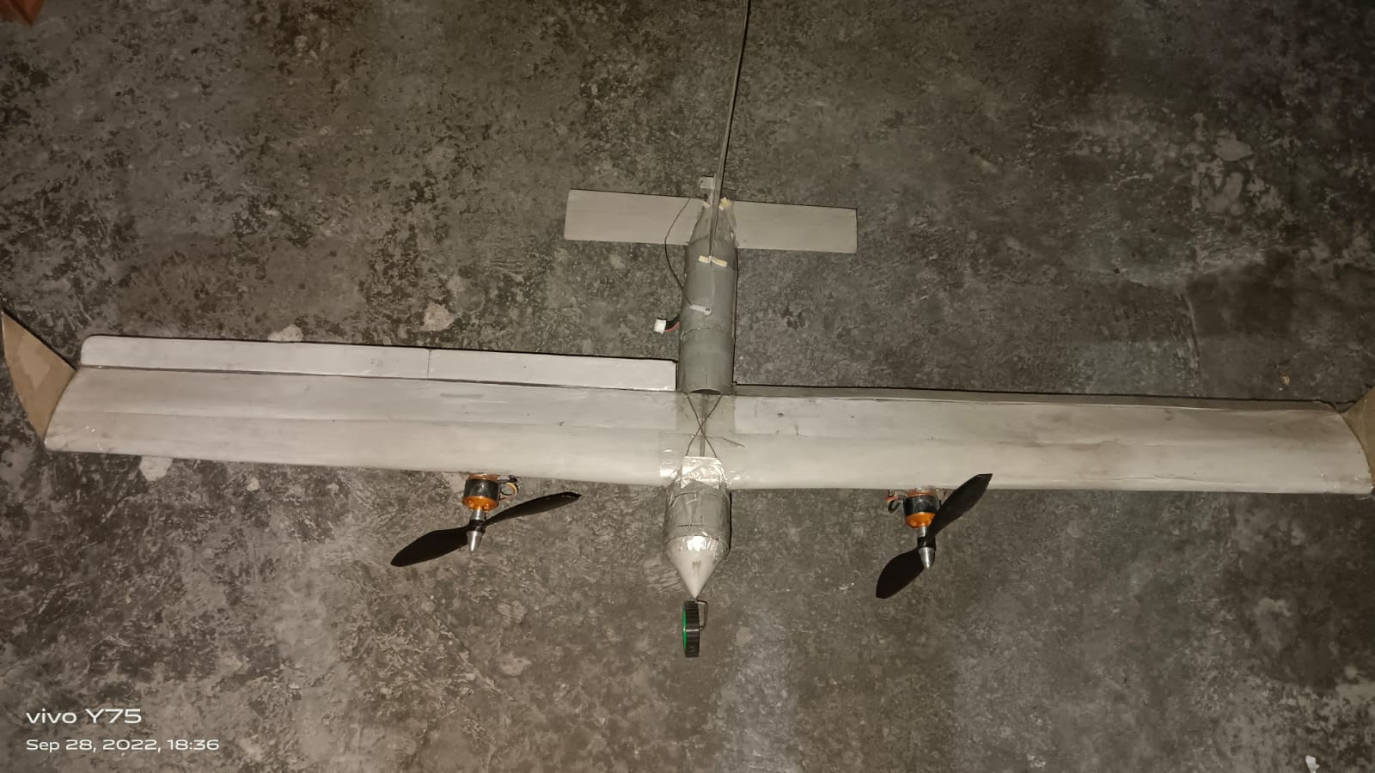

A solar glider vehicle is a type of aircraft that relies on solar power to generate the energy needed for propulsion and flight. These vehicles are equipped with solar panels on their wings or body, which capture sunlight and convert it into electricity to power electric motors or other propulsion systems. Solar gliders are often used for long-endurance flights and environmental research because they can operate for extended periods without the need for traditional fuel sources. They harness the energy of the sun to stay aloft and are designed to be as energy-efficient as possible.

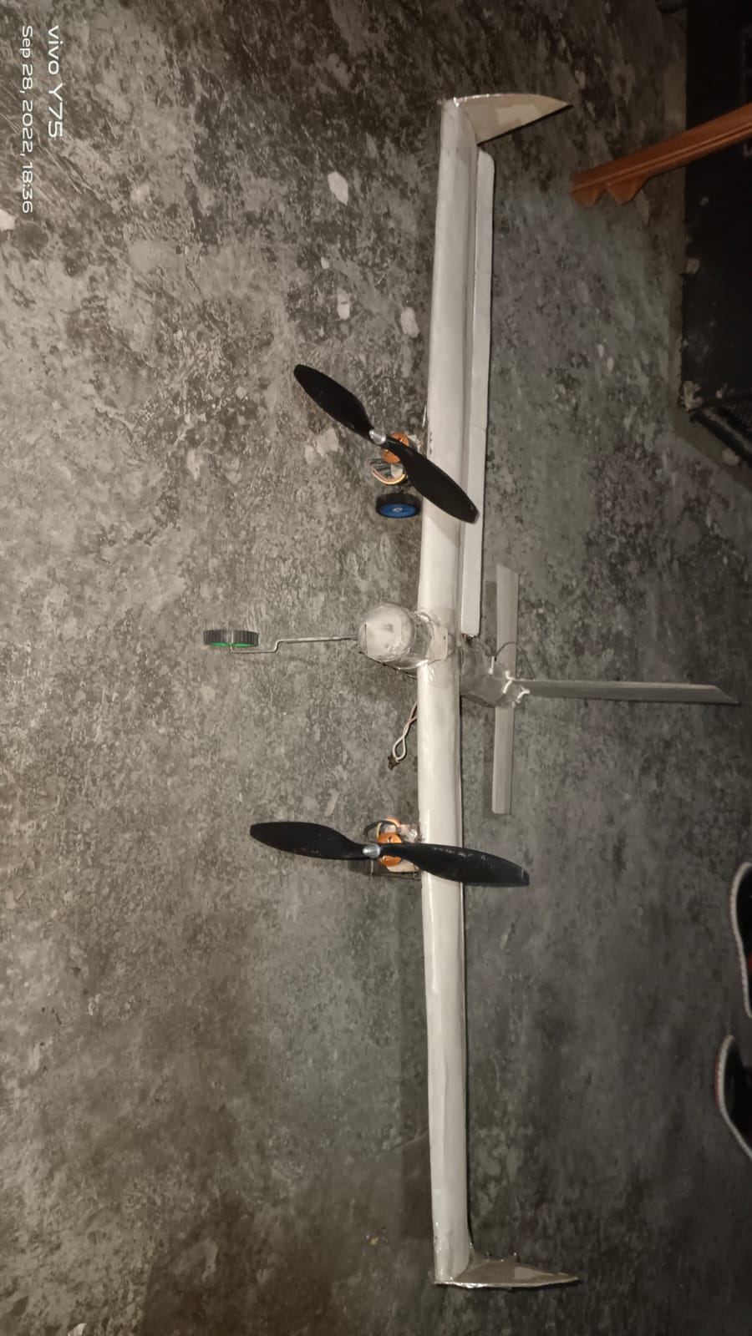

The size of the wings on a solar glider vehicle is typically large for several reasons:

1. Solar Energy Capture: Larger wings provide a greater surface area for solar panels. This allows the vehicle to capture more sunlight and generate more electricity, which is essential for powering the aircraft's propulsion system and maintaining flight.

2. Energy Efficiency: Larger wings can provide more lift, allowing the aircraft to stay aloft with minimal energy consumption. This is crucial for achieving long-endurance flights, which are often the goal of solar glider vehicles.

3. Weight Distribution: Solar gliders need to carry a substantial number of solar panels and the associated electrical components. Larger wings help distribute the weight more evenly, ensuring stability and control during flight.

4. Aerodynamic Efficiency: Larger wings can be designed with improved aerodynamics, reducing drag and enhancing overall efficiency. This allows the vehicle to glide more smoothly and use less energy to maintain flight.

5. Maximum Sun Exposure: Larger wings enable the aircraft to have a larger surface area exposed to the sun, increasing the amount of solar energy that can be harnessed during flight.

It's important to find the right balance in wing size to optimize performance, energy capture, and aerodynamics for a specific solar glider design.

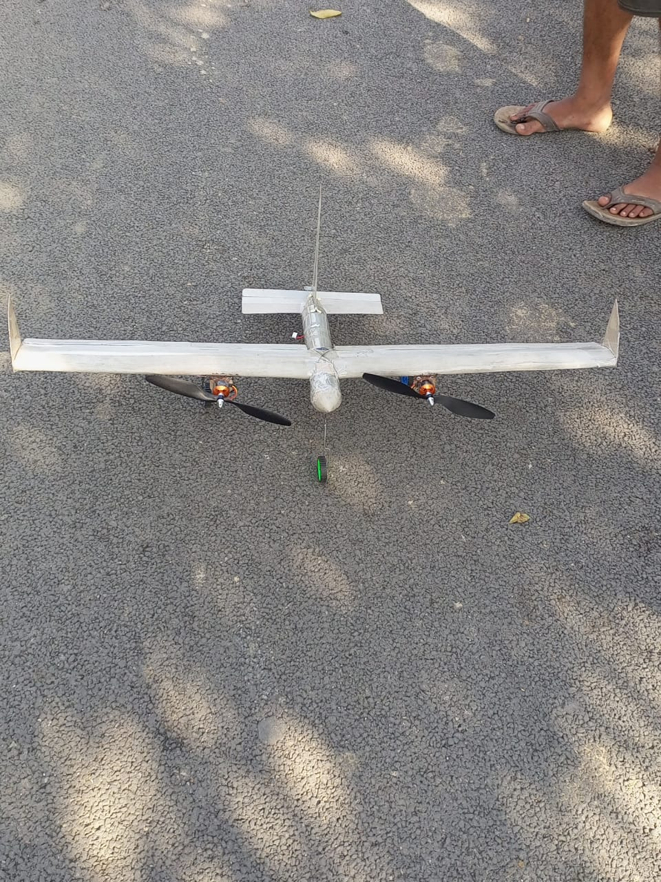

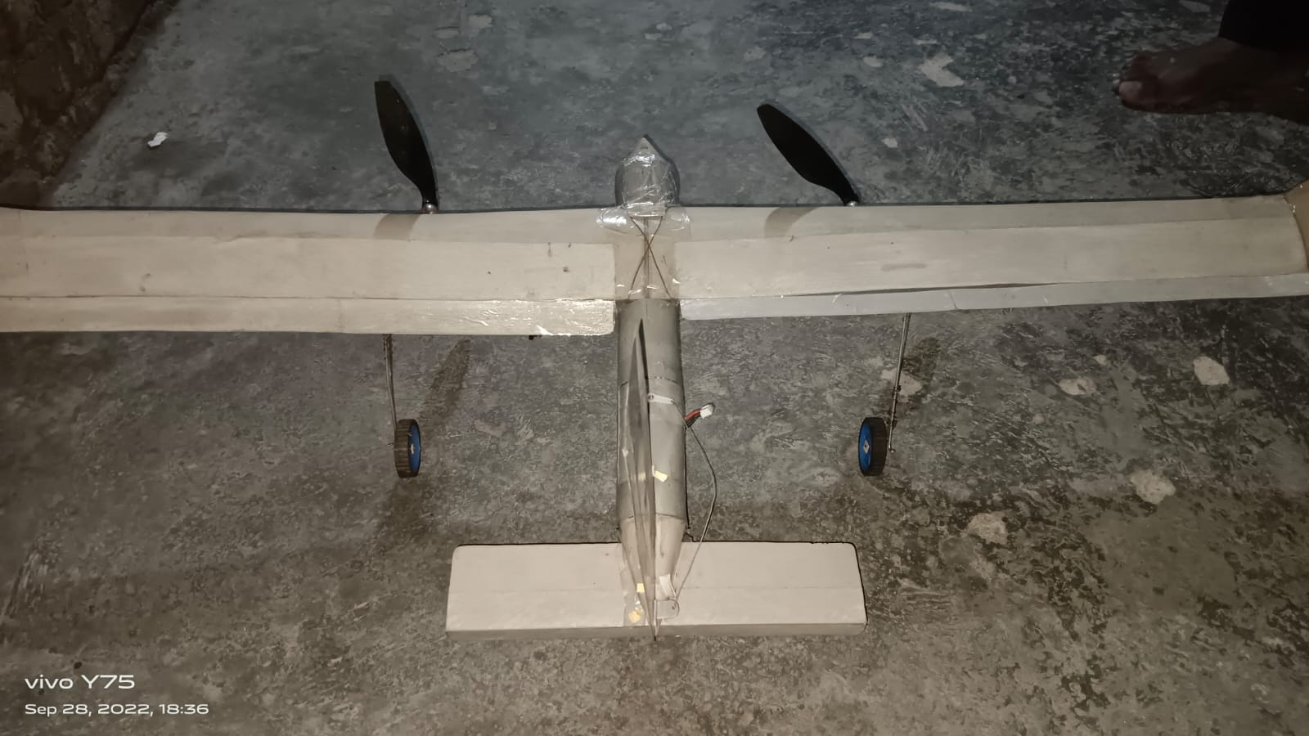

A solar glider vehicle typically consists of several key components, each designed to harness solar energy for propulsion and maintain flight. Here are the essential details for these components:

1. Solar Panels: Solar gliders are equipped with an array of photovoltaic solar panels on their wings and sometimes the fuselage. These panels capture sunlight and convert it into electrical energy to power the vehicle's systems and propulsion.

2. Battery System: Solar gliders often incorporate a high-capacity battery system to store excess solar energy generated during the day. These batteries provide power to the vehicle during the night or when flying through cloudy conditions.

3. Electric Motor: An electric motor is responsible for converting electrical energy from the solar panels and batteries into mechanical energy for propulsion. It drives the propeller or other means of thrust.

4. Lightweight Structure: To maximize energy efficiency, solar gliders are built with lightweight materials such as carbon fiber or composite materials. This reduces the overall weight of the vehicle, improving its glide performance.

5. Wing Design: Solar gliders feature specially designed wings to optimize lift and reduce drag. The wings may have a high aspect ratio for improved glide performance.

6. Control Surfaces: Ailerons, elevators, and rudders enable the pilot or autopilot system to control the glider's attitude and direction.

7. Avionics and Guidance System: Solar gliders may be equipped with advanced avionics and navigation systems to aid in autonomous flight. These systems can optimize the glider's path to maximize solar energy collection.

8. Energy Management System: An energy management system monitors and optimizes the distribution of power between propulsion, avionics, and other onboard systems to ensure efficient operation.

9. Payload Space: Some solar gliders are designed for specific missions and may include payload space for scientific instruments, cameras, or other equipment.

10. Data Transmission: Communication equipment is often included to transmit data collected during flight to a ground station or control center.

11. Ground Control Station: Operators on the ground remotely control and monitor the solar glider's flight, adjusting its path and receiving data from onboard sensors.

12. Safety Systems: Solar gliders may be equipped with safety features, such as backup power systems, emergency parachute deployment mechanisms, and fail-safe navigation options.

13. Maintenance and Serviceability: Like any aircraft, solar gliders require regular maintenance and servicing to ensure their continued operation.

The specific design and components of a solar glider can vary based on its intended purpose, whether it's for environmental monitoring, surveillance, research, or recreational use.